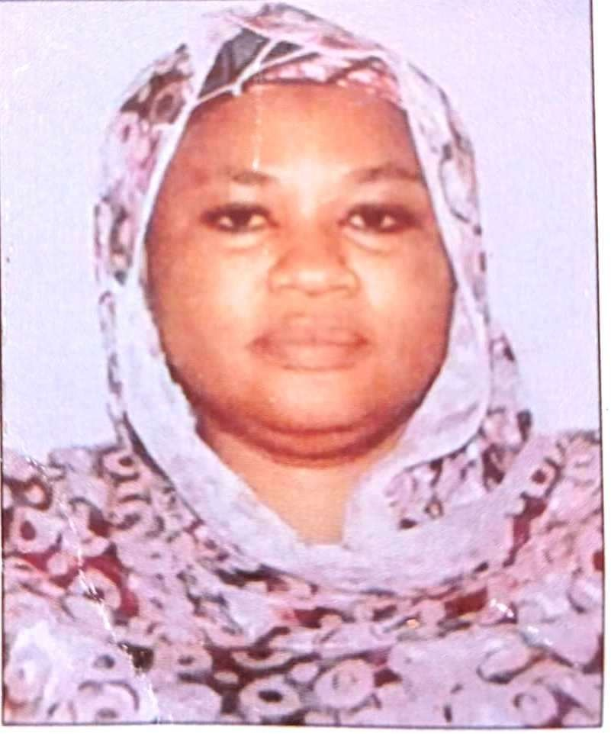

Baba Sama’ila, MARYAM

## Department Of Business Administration & Management, Abubakar Tatari Ali Polytechnic, Bauchi.

**Phone:** +2347035500318,

**E-mail:** [**maryam.m.jibrin@gmail.com**](mailto:maryam.m.jibrin@gmail.com)

# Professional Summary

Versatile professional with over 24 years of accomplished experience in Business Administration and Management in both academics and industries. Proven expertise in strategic leadership, organizational development, project management, and business operations. Adept at fostering collaboration and providing effective guidance to support research initiatives. Known for delivering engaging lectures and implementing detail- oriented classroom management strategies. Committed to achieving individual and organizational success through comprehensive understanding and strategic decision-making.

***Career Objectives***

Aspire to be a pivotal figure in academia and industry, contributing significantly to the realms of Business Administration and Management. To be recognized as a true professional team player, aiming to seamlessly blend academic expertise with practical industry insights to become an indispensable asset in driving success across various sectors.

# Skills

* Leadership
* Strategic Planning
* Communication
* Problem Solving
* Team Building
* Project Management
* Adaptability
* Computer Communication

# Personal Information

* Date of Birth: 12th January, 1970
* Nationality: Nigeria
* Place of Birth: Bauchi
* Sex: Female
* Marital Status: Married
* State: Bauchi
* Local Govt’ Area: Bauchi

# Work History

**2017 – Present Chief Lecturer**

*Abubakar Tatari Ali Polytechnic, School of Management Studies (sms) Business Department Bauchi, Bauchi*

* + Supervised more than 20 junior lecturers' course development and recommended refinements to enhance both undergraduate and graduates’ students learning.
  + Delivered higher-level undergraduate and graduate courses via classroom, online and hybrid methodologies to satisfy course curricula and meet students’ needs

**2012 - 2017**

**2010 – 2012**

## General Manager

*ATAP Consult Bauchi*

* Overseeing daily Business Operations
* Developing & Implementing growth strategies
* Training Low level managers & staff
* Creating & Managing budgets
* Improving revenues
* Hiring employees
* Evaluating performance & financial data.
* Researching & identifying growth opportunities.
* Generating reports & giving presentations.
* Collaborating with external environment on Business operations

## Deputy General Manager - Operations

*ATAP Consult, Bauchi*

* Collaborated with more than 30 departmental heads to establish goals and work plans.
* Applied creative reasoning and logic to resolve complex and specialized managerial issues and develop sound solutions.

**2006 - 2010**

**2007 - 2009**

## Head of Department – Business Admin. & Mangt’.

*Abubakar Tatari Ali Polytechnic, Bauchi*

To train and manage over 23 academic and non-academic staff, conduct research and set other academic goals.

**Part time Member** (Special Schools Management Board Bauchi)

* + Overseeing the activities of the special schools in Bauchi.
  + Developing strategies in terms of problems & Solutions.
  + Evaluating Staff performance.

**2004 - 2006 Program Coordinator**

*Business Admin. & Mangt’. - ATAP, Bauchi*

* + - Organized and managed program development from conception through successful execution.
    - Reserved classrooms and meeting rooms across campus for program activities and managed room list.

# Post/grade level

**2017 – To date** Chief lecturer – 15/8

# Education

**2019 -To date**

**2018 – 2019**

**2001** - **2003**

## PhD Business Administration & Management (Inview)

Nassarawa State University Keffi

## M.Phil Business Administration & Management

Nassarawa State University Keffi

## MBA: Business Administrations

*Abubakar Tafawa Balewa University, (ATBU), Bauchi*

* Completed professional development in Business Administration and Management. and Industrial Relations.

|  |  |
| --- | --- |
| **1990** - **1995** | **BSc: Bachelor of Science: Business Management**  *University of Maiduguri (UNIMAID) – Maiduguri, Borno State.* |
| **1983** - **1988** | **WASC:**  *Government Girls Science Secondary School, Bauchi, Nigeria.* |
| **1976** - **1982** | **Primary School Certificate**  *Jahun Primary School - Bauchi, Nigeria.* |

# Affiliations

* + Member Nigerian Institute of Management (NIM)
  + Institute of Strategic Management Nigeria (ISMN)

# Interests

Research, Teaching, and Travelling.

# Research Publications

Sama’ila, B. M. (2016). Confirmatory Factor Analysis (CFA) First Order Uni-Dimensional Measurement Model for ICT Youths Empowerment in Bauchi State. *Nigerian Journal of Management Technology and Development, ISSN 2006-1676 Vol 7, No.*2, December. Abubakar Tafawa Balewa University, Bauchi.

Sama’ila, B. M. (2010). Managerial Communication Skills: A Means for Business Survival. *Gubi Journal, Federal Polytechnic Bauchi Vol.1, No.6,* September.

Sama’ila, B. M. (2013). Corruption, Educational Inequality and Girl- Child Education in Northern Nigeria. Centre for the promotion of International Relations Studies and Development *(CIRSD), International Journal of Social Science,* Vol 7 No.6, May.

Sama’ila, B. M. (2013). Accessing Finance by African Women Entrepreneurs: A Case Study of North East Nigerian Women Entrepreneurs. Vol 7 No.6, May.

Sama’ila, B. M. (2010). The Application of Financial Ratio in Predicting Business Failure. *Federal Polytechnic Bauchi, Gubi Journal, Vol 1 No.*4, July.

Sama’ila, B. M. (2016). The Relation Between Dircetors’ Competencies, Corporate Governance and Financial Performance: A Proposed Model Publication of Abubakar Tatari Ali Polytechnic Bauchi, Bauchi State Nigeria. *Tatari Ali Academic Journal, Vol 1 No.*2, ISSN 2536-633

Sama’ila, B. M. (2007). Population and Human Resource development.

*Garu Academic Journal, Vo 1 No.*2.

Sama’ila, B. M. (2016). Z-score analysis and analytical tools for measuring financial health of Nigerian manufacturing companies. *Garu Academic journal*, Vol 1 No. 4. ISSN 0189- 9570 August.

# Conferences, Seminars, and Workshops

International conference Dubai. 12th-16th February.

Sama’ila B. M. (2015). Factors influencing sustainable entrepreneurship in SMEs Nigerian experience. 2nd – 4th May, Bauchi, Bauchi State.

Sama’ila B. M. (2017). Forensic auditing and its contribution to corporate governance in Nigeria. Conference Jigawa State Polytechnic Dutse.

7th – 9th March.

Sama’ila B. M. (2014). Ethic and cognitive bias in research: Evidence from Nigerian Tertiary Institution. Global Academic Network

# Referees

### Prof. Ibrahim Saleh

Department of Business Administration and Management, Dean Faculty of management sciences, Federal University Kashere, Gombe, Gombe State (FUK), Nigeria.

**Phone:** +2348036525276**, +**2348025593755

**Email:** [ibrahimadamusaleh3@gmail.com](mailto:ibrahimadamusaleh3@gmail.com)

### Prof. Hassan Barau

Abubakar Tafawa Balewa University, department of Information Technology.

**Phone:** +2348030720702

**Email:** [bshassan@atbu.edu.ng](mailto:bshassan@atbu.edu.ng)

### Dr. Halima Mohammed Ladan

Head of Department, Sciences Laboratory Technology, Faculty of Science

Abubakar Tatari Ali Polytechnic, Bauchi – Nigeria.

**Phone:** +2348061555125

**Email:** [halimaladan68@gmail.com](mailto:halimaladan68@gmail.com)